**SQL Assessment**

1. Top 5 cities from most flights taken off

1. Top 5 cities where the most flights landed

1. Most flown route (from and to)

1. Airlines with most cancellation or deviation

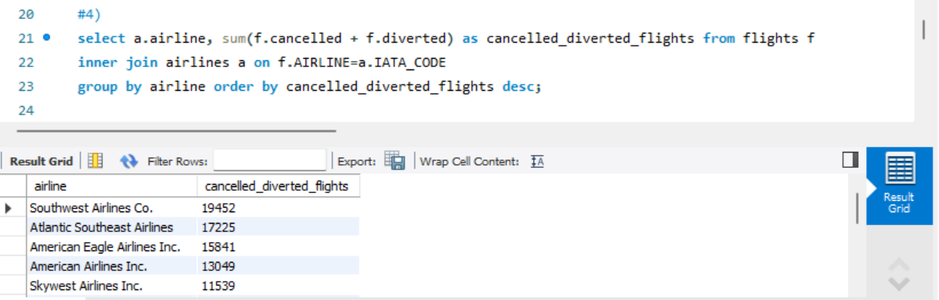

1. Busiest hour of the day when flights take off

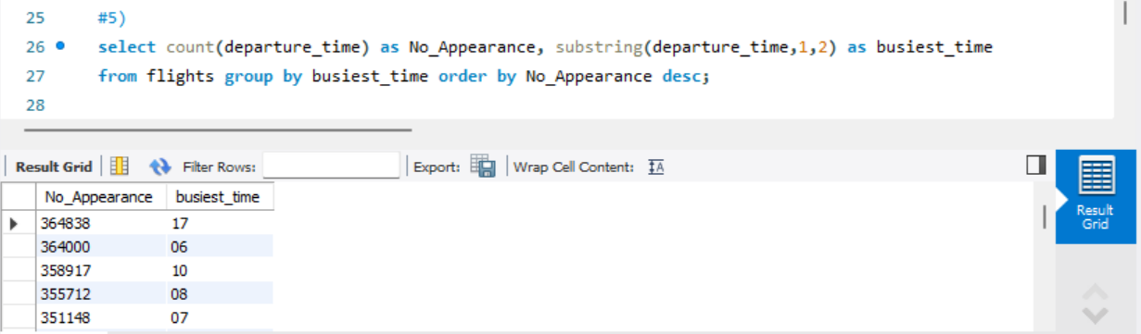

1. How many flights take off each month

1. Which city and Day of week has the highest traffic

*Chicago has the highest traffic*

1. List the average arrival delay and departure delay for all the airlines

1. Create a table with Airline and Cancellation reason with number of times

1. Count the number of Nulls in any 5 columns of your choice

1. What is the month-on-month %change in number of flights per airline from Jan to Feb (Show Airline Name)?

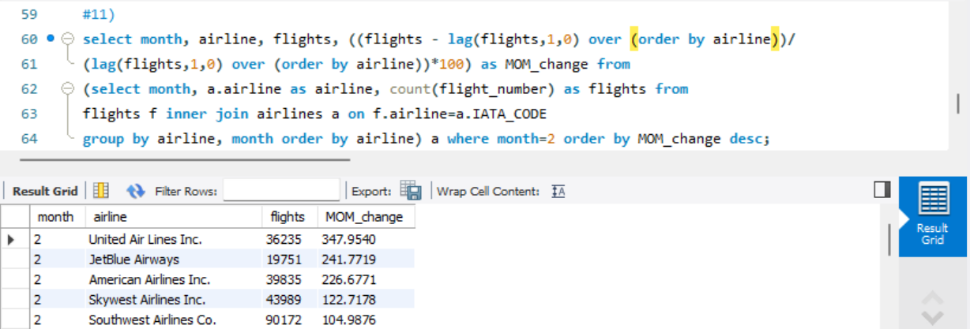

1. What is the month-on-month %change in number of delays per airline from Jan to Feb (Show Airline Name)?

1. Rank the airlines by least delays in arrival by month and then find out the change in rank from previous month

